LAPORAN PENGERJAAN UJIKOMPETENSI KEJURUAN

SMK MAHARDHIKA BATUJAJAR

TAHUN PELAJARAN 2022-2023

KOMPETENSIKEAHLIAN :RekayasaPerangkatLunakKELAS : XII RPL 1

NAMALENGKAP :RizkiNurHalim

NIS :

PAKETSOAL : 2

JENISAPLIKASI :Web Pengaduan Masyarakat

ALOKASIWAKTU :24jam

# PENJADWALANKEGIATAN

|  |  |  |  |  |  |  |  |  |  |  |  |  |  |  |  |  |  |  |  |  |  |  |  |  |  |  |
| --- | --- | --- | --- | --- | --- | --- | --- | --- | --- | --- | --- | --- | --- | --- | --- | --- | --- | --- | --- | --- | --- | --- | --- | --- | --- | --- |
| No. | Kegiatan | Alokasi Waktu | | | | | | | | | | | | | | | | | | | | | | | | Keterangan |
| 1 | 2 | 3 | 4 | 5 | 6 | 7 | 8 | 9 | 10 | 11 | 12 | 13 | 14 | 15 | 16 | 17 | 18 | 19 | 20 | 21 | 22 | 23 | 24 |
| 1. | Analisis Soal |  |  |  |  |  |  |  |  |  |  |  |  |  |  |  |  |  |  |  |  |  |  |  |  |  |
| 2. | Persiapan Perangkat |  |  |  |  |  |  |  |  |  |  |  |  |  |  |  |  |  |  |  |  |  |  |  |  |  |
| 3. | Persiapan Software |  |  |  |  |  |  |  |  |  |  |  |  |  |  |  |  |  |  |  |  |  |  |  |  |  |
| 4. | Perancangan Algoritma |  |  |  |  |  |  |  |  |  |  |  |  |  |  |  |  |  |  |  |  |  |  |  |  |  |
| 5. | Desain Database |  |  |  |  |  |  |  |  |  |  |  |  |  |  |  |  |  |  |  |  |  |  |  |  |  |
| 6. | Implementasi Database/Buat Ke MySQL |  |  |  |  |  |  |  |  |  |  |  |  |  |  |  |  |  |  |  |  |  |  |  |  |  |
| 7. | Desain User Interface |  |  |  |  |  |  |  |  |  |  |  |  |  |  |  |  |  |  |  |  |  |  |  |  |  |
| 8. | Implementasi Kode Program |  |  |  |  |  |  |  |  |  |  |  |  |  |  |  |  |  |  |  |  |  |  |  |  |  |
| 9. | Uji Coba Aplikasi |  |  |  |  |  |  |  |  |  |  |  |  |  |  |  |  |  |  |  |  |  |  |  |  |  |
| 10. | Uji Cetak Struk |  |  |  |  |  |  |  |  |  |  |  |  |  |  |  |  |  |  |  |  |  |  |  |  |  |
| 11. | Uji Coba Buat Laporan |  |  |  |  |  |  |  |  |  |  |  |  |  |  |  |  |  |  |  |  |  |  |  |  |  |
| 12. | Upload Ke Hosting |  |  |  |  |  |  |  |  |  |  |  |  |  |  |  |  |  |  |  |  |  |  |  |  |  |
| 13. | Dokumentasi |  |  |  |  |  |  |  |  |  |  |  |  |  |  |  |  |  |  |  |  |  |  |  |  |  |

# PERSIAPANPERANGKATKERAS

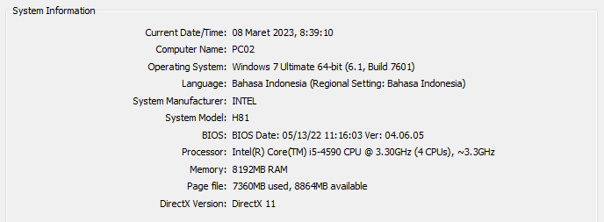

# PERSIAPANPERANGKATLUNAK

* Astah
* Balsamiq
* XAMPP Control Panel
* Visual Code Studio
* Chrome

# PERANCANGANALGORITMAAPLIKASI

# Activity diagram

# Activity diagram login

# C:\Users\USER\AppData\Local\Microsoft\Windows\INetCache\Content.Word\Login pengaduan.jpg

# Activity Diagram Register

# 

# Activity diagram Membuat PengaduanD:\tugas pbo\Activity Diagram0.jpg

# Activity Diagram Menanggapi/Admin/Petugas

# D:\tugas pbo\Activity Diagram menangapi pengaduan0.jpg

# Tambah data User/admin

# D:\tugas pbo\Activity Diagram menangapi pengaduan12.jpg

# Edit data user User/admin

# D:\tugas pbo\Edit data.jpg

# Activity diagram Hapus tanggapan

# D:\tugas pbo\hapus tangapan.jpg

# Hapus data user

# D:\tugas pbo\Hapus data user.jpg

# PERANCANGANDESAINBASISDATA

# Class diagram

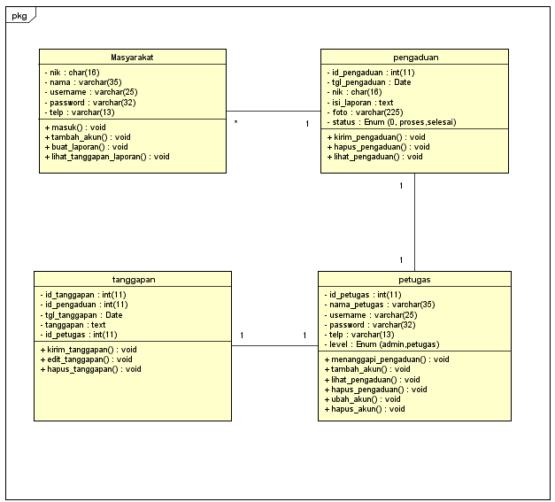

# ERD

# 

# DUMMYDATA

# Masyarakat

|  |  |  |  |  |
| --- | --- | --- | --- | --- |
| **NIK** | **Nama** | **Username** | **Password** | **Telepon** |
| 00877845623 | M riski | Masyarakat | masyarakat | 088876159678 |
| 00848965890 | Nao | Nao | Takeru12 | 086785479456 |
| 00869764876 | Dani | Dhani | Dani12 | 082455458965 |
| 00897896098 | Tono | Tony | Toni09 | 087896512345 |
| 08898747839 | Bayu | Bayu12 | Bayi69 | 086526612890 |

* **Petugas**

|  |  |  |  |  |  |
| --- | --- | --- | --- | --- | --- |
| **ID Petugas** | **Nama Petugas** | **Username** | **Password** | **Telepon** | **Level** |
| 008746920 | M lim | Admin | admin | 088137819087 | Admin |
| 008236890 | Karim | Squre | Bulat12 | 086735897457 | Petugas |
| 008234346 | Jani | Janin | Bayi98 | 084398795455 | Petugas |
| 008123579 | Allysa | Ashira | Alya12 | 088236738923 | Admin |
| 008534789 | Nanami | Nana | Gajah69 | 086324672813 | Petugas |

* **Pengaduan**

|  |  |  |  |  |  |
| --- | --- | --- | --- | --- | --- |
| **ID Pengaduan** | **Tanggal Pengaduan** | **NIK** | **Isi Laporan** | **Foto** | **Status** |
| 023 | 2023-01-15 | 008746920 | Jalan jelek | Jalan.jpg | Proses |
| 024 | 2023-02-01 | 008236890 | Banjir | Banjir.jpg | Selesai |
| 025 | 2023-03-09 | 008236890 | Longsor | 723468.jpg | Proses |
| 027 | 2023-01-12 | 008123579 | Bausampah | Sampah.jpg | Proses |
| 026 | 2023-02-18 | 008534789 | Banyaktikus | 31238.jpg | selesai |

# PEMBUATANBASISDATA(MySQLCode)

* **Database Masyarakat**

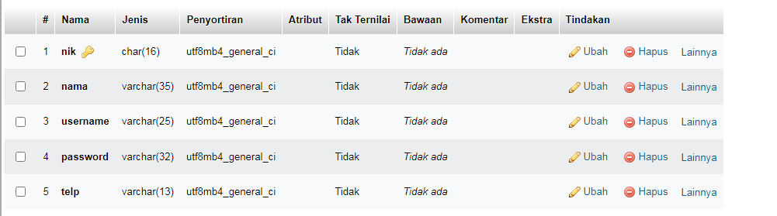

* **Database Petugas**

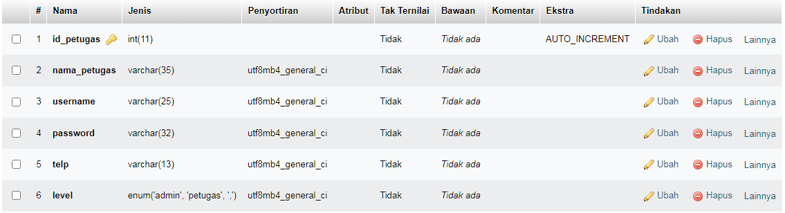

* **Database Pengaduan**

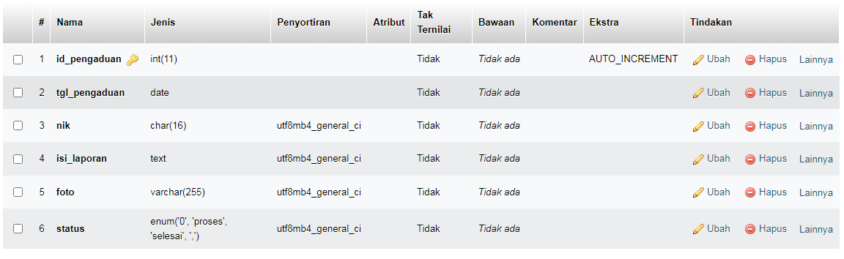

* **Database Tanggapan**

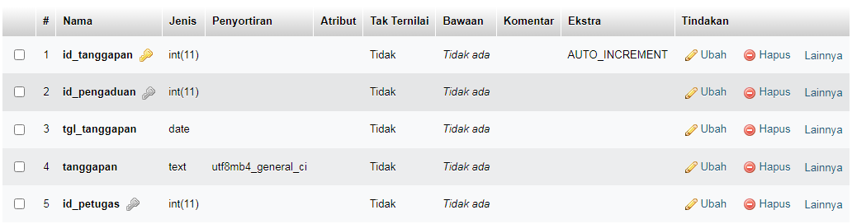

# PERANCANGANTAMPILANANTARMUKA(UI)WEB

* + **Aplikasi pengaduan masyarakat**

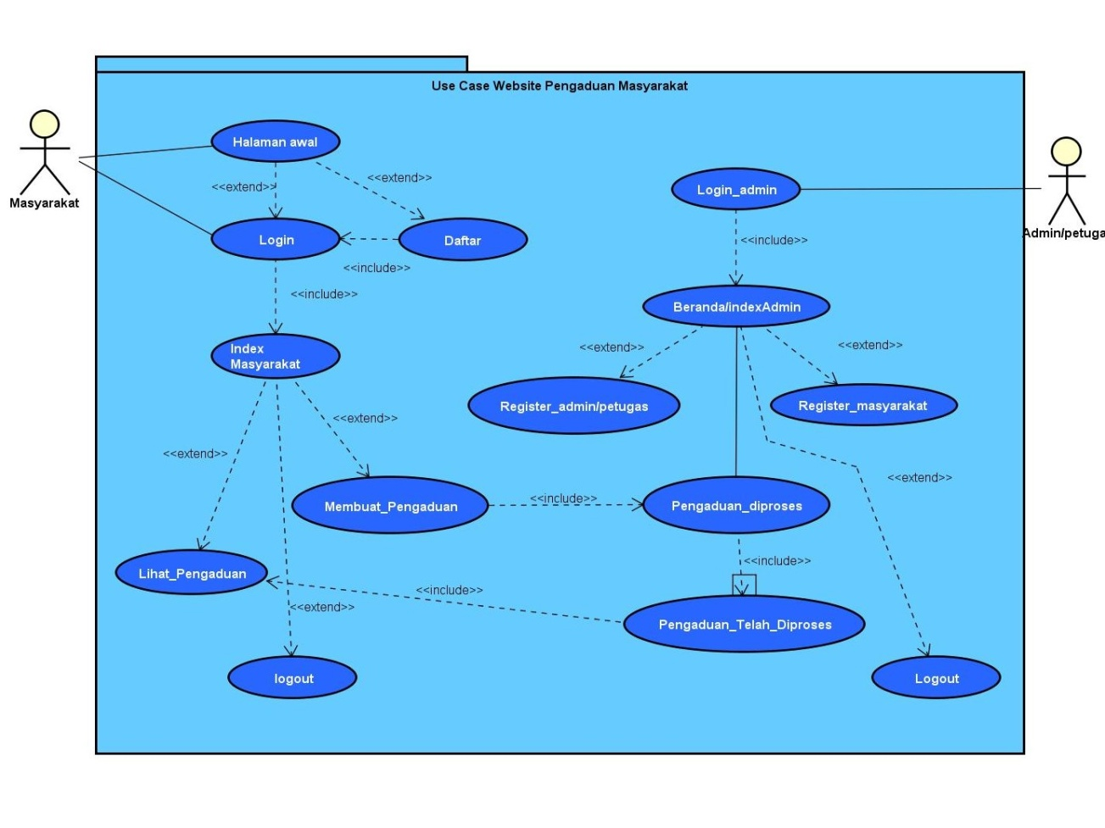

1. Admin dashboard

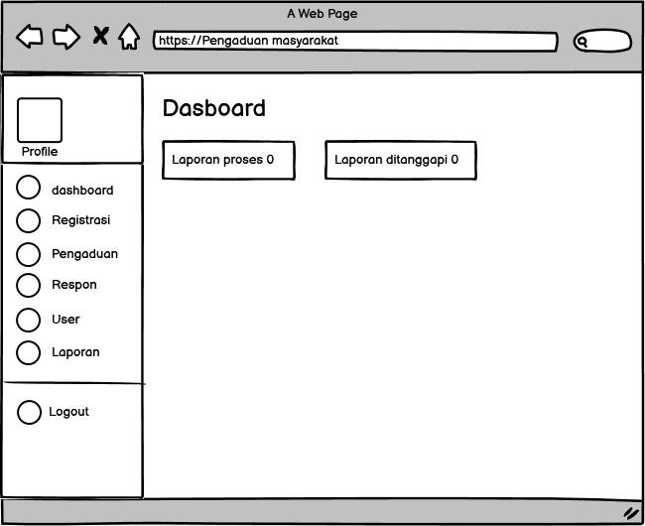

* From Tamabah akun Masyarakat di admin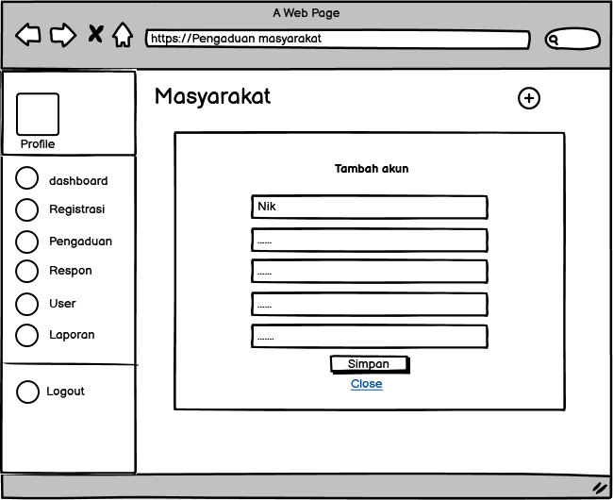
* From Register Admin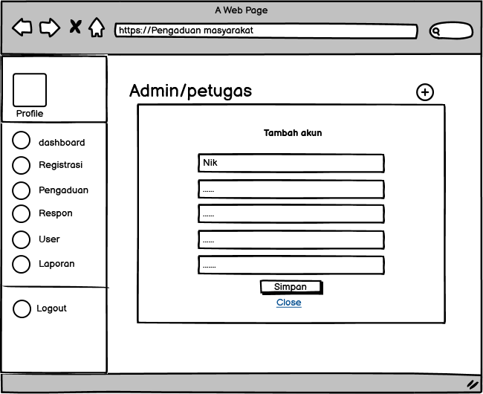

1. Tampilan Petugas

* Dash board Petugas

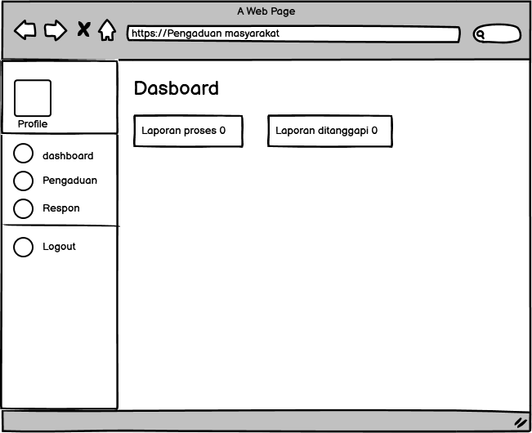

* From Menanggapi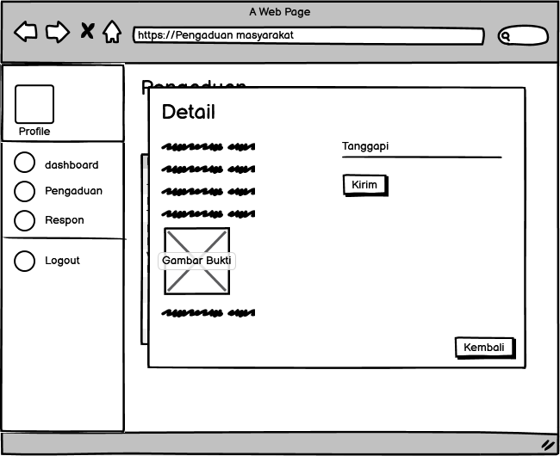

1. Tampilan Masyarakat

* Dashboard Masyarkat

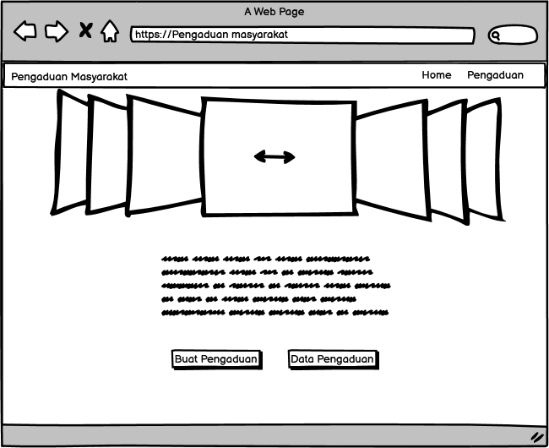

* Buat Pengaduan

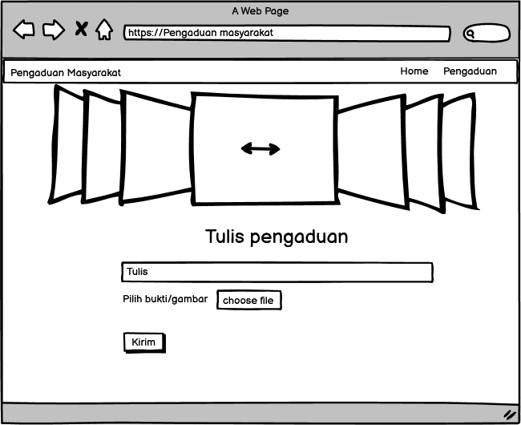

* Data Pengaduan

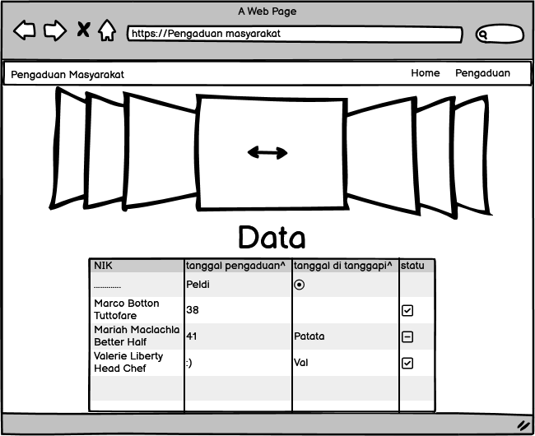

# PEMBUATANSTRUKTURWEB(HTML)

<!DOCTYPE html>

<html>

<head>

<meta charset="utf-8">

<title>Pengaduan!</title>

<link rel="stylesheet" href="css/container.css">

</head>

<body>

<div class="fConteiner">

<nav class="wrapper">

<div class="brand">

<div class="fristname">Pengaduan</div>

<div class="lastname">Masyarakat</div>

</div>

<ul class="navigation">

<li><a href="from-login.php">Login</a></li>

<li><a href="register.php" class="active">Daftar</a></li>

</ul>

</nav>

</div>

<div >

<main>

<div class="slide">

<div class="kanan">

<span id="slide-1"></span>

<span id="slide-2"></span>

<span id="slide-3"></span>

<div class="image">

<img src="img/image2.jpg">

<img src="img/image1.jpg">

<img src="img/image3.jpg">

</div>

</div>

<!-- navigasi -->

<div class="geser">

<a href="#slide-1">1</a>

<a href="#slide-2">2</a>

<a href="#slide-3">3</a>

</div>

</div>

</main>

<aside>

<div><h1>Layanan Aspirasi dan Pengaduan Online Rakyat</h1><br></div>

<h3>Sampaikan laporan Anda langsung kepada <br>instansi pemerintah berwenang</h3>

<br>

<h2> Sebelum Melapor Wajib Login atau daftar</h2>

</aside>

</div>

<!-- <footer>

</footer> -->

</div>

</body>

</html>

</nav>

</div>

<div >

<main>

<div class="slide">

<div class="kanan">

<span id="slide-1"></span>

<span id="slide-2"></span>

<span id="slide-3"></span>

<div class="image">

<img src="img/image2.jpg">

<img src="img/image1.jpg">

<img src="img/image3.jpg">

</div>

</div>

<!-- navigasi -->

<div class="geser">

<a href="#slide-1">1</a>

<a href="#slide-2">2</a>

<a href="#slide-3">3</a>

</div>

</div>

</main>

<aside>

<div><h1>Layanan Aspirasi dan Pengaduan Online Rakyat</h1><br></div>

<h3>Sampaikan laporan Anda langsung kepada <br>instansi pemerintah berwenang</h3>

<br>

<h2> Sebelum Melapor Wajib Login atau daftar</h2>

</aside>

</div>

<!-- <footer>

</footer> -->

</div>

</body>

</html>

1. PEMBUATAN STYLEWEB (CSS)

@import url('https://fonts.googleapis.com/css2?family=Sofia+Sans+Semi+Condensed:wght@600&display=swap');

*, html{

font-size: 20px;

margin: 0;

font-family: 'Sofia Sans Semi Condensed', sans-serif;

box-sizing: border-box;

}

body{

margin: 0;

padding: 0;

}

h1 {

font-family: 'Lato', sans-serif;

font-weight: 300;

letter-spacing: 2px;

font-size: 40px;

}

h3{

font-size: 20px;

}

header, main, footer{

display: flex;

text-align: center;

justify-content: center;

}

/* header{

width: 100%;

height: 100px;

background: aqua;

} */

/* nav{

width: 100%;

height: 90px;

background: grey;

} */

.fConteiner {

display: flex;

width: 100%;

height: 10vh;

background-color: lightgrey;

}

.wrapper{

display: flex;

font-size: 20px;

padding: 15px;

justify-content: space-between;

align-items: center;

width: 100%;

height: 80px;

background-color: black;

color: white;

box-shadow: 0 7px 15px 0 rgba(0, 0, 0, 0.5);

}

.brand {

display: flex;

flex-direction: row;

font-size: 1.5em;

padding: 15px;

text-transform: capitalize;

}

.fristname{

color: white;

font-weight: 700;

}

.lastname{

color: grey;

padding-left: 4px;

}

.navigation {

display: flex;

justify-content: center;

align-items: center;

}

.navigation >li {

list-style-type: none;

padding: 15px;

}

.navigation >li >a {

color: white;

font-size: 17px;

text-decoration: none;

text-transform: capitalize;

}

.navigation>li>a:hover {

color: grey;

transition: all .3s ease-in-out;

}

.active {

background-color: gray;

color: white;

padding: 15px;

}

.active:hover {

color: white !important;

}

main{

width: 100%;

height: 600px;

background-image: url("/img/login.jpg");

background-color: #cccccc;

}

.image{

display: flex;

width: 100%;

transition: 2s;

}

.image img{

width: 100%;

}

.slide{

width: 900px;

margin: auto;

border-radius: 5px;

overflow: hidden;

position: relative;

}

#slide-1:target ~ .image {

margin-left: 0px;

}

#slide-2:target ~ .image {

margin-left: -100%;

}

#slide-3:target ~ .image {

margin-left: -200%;

}

.geser a{

display: inline-block;

height: 25px;

width: 25px;

background-color: azure;

font-size: 0px;

border-radius: 50%;

margin: 3px;

transition: 1s;

}

.geser a:hover {

background-color: lightgrey;

}

.geser {

position: absolute;

margin-left: auto;

margin-right: auto;

left: 0;

right: 0;

text-align: center;

margin-top: -50px;

}

@media screen and (max-width: 800px){

.wrapper {

width: 90%;

}

}

aside{

width: 100%;

height: 450px;

background: lightgrey;

text-align: center;

justify-content: center;

}

.fcc-btn {

background-color: green;

color: white;

padding: 15px 25px;

text-decoration: none;

border-radius: 5%;

}

.fcc-btn:hover {

background-color: #223094;

}

footer{

width: 100%;

height: 110px;

background: aqua;

}

.area{

width: 100%;

background: transparent;

border-radius: 5px;

padding: 25px 25px 30px;

}

.area h2{

color: black;

font-size: 50px;

text-align: center;

}

.area textarea{

width: 50%;

height: 59px;

padding: 15px;

border-radius: 5px;

outline: none;

resize: none;

font-size: 20px;

margin-top: 5px;

border-radius: 5px;

border-color: black;

}

textarea :is(:focus, :valid){

border-color: white;

padding: 14px;

border-color: aqua;

}

textarea::-webkit-scrollbar{

width: 0px;

}

input[type="file"]::file-selector-button {

border: 2px solid #6c5ce7;

padding: 0.2em 0.4em;

border-radius: 0.2em;

background-color: white;

transition: 1s;

}

input[type="file"]::-ms-browse:hover {

background-color: #81ecec;

border: 2px solid grey;

}

input[type="file"]::-webkit-file-upload-button:hover {

background-color: #81ecec;

border: 2px solid grey;

}

input[type="file"]::file-selector-button:hover {

background-color: gray;

border: 2px solid #00cec9;

}

label{

font-size: 30px;

}

.z-depth-5, .modal {

-webkit-box-shadow: 0 24px 38px 3px rgba(0, 0, 0, 0.14), 0 9px 46px 8px rgba(0, 0, 0, 0.12), 0 11px 15px -7px rgba(0, 0, 0, 0.2);

box-shadow: 0 24px 38px 3px rgba(0, 0, 0, 0.14), 0 9px 46px 8px rgba(0, 0, 0, 0.12), 0 11px 15px -7px rgba(0, 0, 0, 0.2);

}

.modal {

display: none;

position: fixed;

left: 0;

right: 0;

background-color: #fafafa;

padding: 0;

max-height: 70%;

width: 55%;

margin: auto;

overflow-y: auto;

border-radius: 2px;

will-change: top, opacity;

}

.modal:focus {

outline: none;

}

@media only screen and (max-width: 992px) {

.modal {

width: 80%;

}

}

.modal h1, .modal h2, .modal h3, .modal h4 {

margin-top: 0;

}

.modal .modal-content {

padding: 24px;

}

.modal .modal-close {

cursor: pointer;

}

.modal .modal-footer {

border-radius: 0 0 2px 2px;

background-color: #fafafa;

padding: 4px 6px;

height: 56px;

width: 100%;

text-align: right;

}

.modal .modal-footer .btn, .modal .modal-footer .btn-large, .modal .modal-footer .btn-small, .modal .modal-footer .btn-flat {

margin: 6px 0;

}

.modal-overlay {

position: fixed;

z-index: 999;

top: -25%;

left: 0;

bottom: 0;

right: 0;

height: 125%;

width: 100%;

background: #000;

display: none;

will-change: opacity;

}

.modal.modal-fixed-footer {

padding: 0;

height: 70%;

}

.modal.modal-fixed-footer .modal-content {

position: absolute;

height: calc(100% - 56px);

max-height: 100%;

width: 100%;

overflow-y: auto;

}

.modal.modal-fixed-footer .modal-footer {

border-top: 1px solid rgba(0, 0, 0, 0.1);

position: absolute;

bottom: 0;

}

.modal.bottom-sheet {

top: auto;

bottom: -100%;

margin: 0;

width: 100%;

max-height: 45%;

border-radius: 0;

will-change: bottom, opacity;

}

.datepicker-modal {

max-width: 325px;

min-width: 300px;

max-height: none;

}

.datepicker-container.modal-content {

display: -webkit-box;

display: -webkit-flex;

display: -ms-flexbox;

display: flex;

-webkit-box-orient: vertical;

-webkit-box-direction: normal;

-webkit-flex-direction: column;

-ms-flex-direction: column;

flex-direction: column;

padding: 0;

}

@media only screen and (min-width: 601px) {

.datepicker-modal {

max-width: 625px;

}}

.datepicker-container.modal-content {

-webkit-box-orient: horizontal;

-webkit-box-direction: normal;

-webkit-flex-direction: row;

-ms-flex-direction: row;

flex-direction: row;

}

.timepicker-modal {

max-width: 325px;

max-height: none;

}

.timepicker-container.modal-content {

display: -webkit-box;

display: -webkit-flex;

display: -ms-flexbox;

display: flex;

-webkit-box-orient: vertical;

-webkit-box-direction: normal;

-webkit-flex-direction: column;

-ms-flex-direction: column;

flex-direction: column;

padding: 0;

}

@media only screen and (min-width: 601px) {

.timepicker-modal {

max-width: 600px;

}

.timepicker-container.modal-content {

-webkit-box-orient: horizontal;

-webkit-box-direction: normal;

-webkit-flex-direction: row;

-ms-flex-direction: row;

flex-direction: row;

}}

.col .row {

margin-left: -0.75rem;

margin-right: -0.75rem;

}

.row .col {

float: left;

-webkit-box-sizing: border-box;

box-sizing: border-box;

padding: 0 0.75rem;

min-height: 1px;

}

.input-field.col .dropdown-content [type="checkbox"] + label {

top: 1px;

left: 0;

height: 18px;

-webkit-transform: none;

transform: none;

}

.input-field.col .prefix ~ label,

.input-field.col .prefix ~ .validate ~ label {

width: calc(100% - 3rem - 1.5rem);

}

.fConteiner {

display: flex;

width: 100%;

height: 10vh;

background-color: lightgrey;

}

.wrapper{

display: flex;

font-size: 20px;

padding: 15px;

justify-content: space-between;

align-items: center;

width: 100%;

height: 80px;

background-color: black;

color: white;

box-shadow: 0 7px 15px 0 rgba(0, 0, 0, 0.5);

}

.brand {

display: flex;

flex-direction: row;

font-size: 1.5em;

padding: 15px;

text-transform: capitalize;

}

.fristname{

color: white;

font-weight: 700;

}

.lastname{

color: grey;

padding-left: 4px;

}

.navigation {

display: flex;

justify-content: center;

align-items: center;

}

.navigation >li {

list-style-type: none;

padding: 15px;

}

.navigation >li >a {

color: white;

font-size: 17px;

text-decoration: none;

text-transform: capitalize;

}

.navigation>li>a:hover {

color: grey;

transition: all .3s ease-in-out;

}

.active {

background-color: gray;

color: white;

padding: 15px;

}

.active:hover {

color: white !important;

}

main{

width: 100%;

height: 600px;

background-image: url("/img/login.jpg");

background-color: #cccccc;

}

.image{

display: flex;

width: 100%;

transition: 2s;

}

.image img{

width: 100%;

}

.slide{

width: 900px;

margin: auto;

border-radius: 5px;

overflow: hidden;

position: relative;

}

#slide-1:target ~ .image {

margin-left: 0px;

}

#slide-2:target ~ .image {

margin-left: -100%;

}

#slide-3:target ~ .image {

margin-left: -200%;

}

.geser a{

display: inline-block;

height: 25px;

width: 25px;

background-color: azure;

font-size: 0px;

border-radius: 50%;

margin: 3px;

transition: 1s;

}

.geser a:hover {

background-color: lightgrey;

}

.geser {

position: absolute;

margin-left: auto;

margin-right: auto;

left: 0;

right: 0;

text-align: center;

margin-top: -50px;

}

@media screen and (max-width: 800px){

.wrapper {

width: 90%;

}

}

.active {

background-color: gray;

color: white;

padding: 15px;

}

.active:hover {

color: white !important;

}

main{

width: 100%;

height: 600px;

background-image: url("/img/login.jpg");

background-color: #cccccc;

}

.image{

display: flex;

width: 100%;

transition: 2s;

}

.image img{

width: 100%;

}

.slide{

width: 900px;

margin: auto;

border-radius: 5px;

overflow: hidden;

position: relative;

}

#slide-1:target ~ .image {

margin-left: 0px;

}

#slide-2:target ~ .image {

margin-left: -100%;

}

#slide-3:target ~ .image {

margin-left: -200%;

}

.geser a{

display: inline-block;

height: 25px;

width: 25px;

background-color: azure;

font-size: 0px;

border-radius: 50%;

margin: 3px;

transition: 1s;

}

.geser a:hover {

background-color: lightgrey;

}

.geser {

position: absolute;

margin-left: auto;

margin-right: auto;

left: 0;

right: 0;

text-align: center;

margin-top: -50px;

}

@media screen and (max-width: 800px){

.wrapper {

width: 90%;

}

}

aside{

width: 100%;

height: 450px;

background: lightgrey;

text-align: center;

justify-content: center;

}

.fcc-btn {

background-color: green;

color: white;

padding: 15px 25px;

text-decoration: none;

border-radius: 5%;

}

.fcc-btn:hover {

background-color: #223094;

}

footer{

width: 100%;

height: 110px;

background: aqua;

}

.area{

width: 100%;

background: transparent;

border-radius: 5px;

padding: 25px 25px 30px;

}

.area h2{

color: black;

font-size: 50px;

text-align: center;

}

.area textarea{

width: 50%;

height: 59px;

padding: 15px;

border-radius: 5px;

outline: none;

resize: none;

font-size: 20px;

margin-top: 5px;

border-radius: 5px;

border-color: black;

}

textarea :is(:focus, :valid){

border-color: white;

padding: 14px;

border-color: aqua;

}

textarea::-webkit-scrollbar{

width: 0px;

}

.geser a{

display: inline-block;

height: 25px;

width: 25px;

background-color: azure;

font-size: 0px;

border-radius: 50%;

margin: 3px;

transition: 1s;

}

.geser a:hover {

background-color: lightgrey;

}

.geser {

position: absolute;

margin-left: auto;

margin-right: auto;

left: 0;

right: 0;

text-align: center;

margin-top: -50px;

}

@media screen and (max-width: 800px){

.wrapper {

width: 90%;

}

}

aside{

width: 100%;

height: 450px;

background: lightgrey;

text-align: center;

justify-content: center;

}

.fcc-btn {

background-color: green;

color: white;

padding: 15px 25px;

text-decoration: none;

border-radius: 5%;

}

.fcc-btn:hover {

background-color: #223094;

}

footer{

width: 100%;

height: 110px;

background: aqua;

}

.area{

width: 100%;

background: transparent;

border-radius: 5px;

padding: 25px 25px 30px;

}

.area h2{

color: black;

font-size: 50px;

text-align: center;

}

.area textarea{

width: 50%;

height: 59px;

padding: 15px;

border-radius: 5px;

outline: none;

resize: none;

font-size: 20px;

margin-top: 5px;

border-radius: 5px;

border-color: black;

}

textarea :is(:focus, :valid){

border-color: white;

padding: 14px;

border-color: aqua;

}

textarea::-webkit-scrollbar{

width: 0px;

}

.area{

width: 100%;

background: transparent;

border-radius: 5px;

padding: 25px 25px 30px;

}

.area h2{

color: black;

font-size: 50px;

text-align: center;

}

1. PEMBUATANKODEWEB(PHP/JS)

* Index.php

<?php

session_start();

error_reporting(0);

include '../conn/koneksi.php';

if(!isset($_SESSION['username'])){

header('location:../index.php');

}

elseif($_SESSION['level'] != "masyarakat"){

header('location:../index.php');

}

?>

<!DOCTYPE html>

<html>

<head>

<meta charset="utf-8">

<title>Pengaduan!</title>

<link rel="stylesheet" href="../css/container.css">

</head>

<body>

<div class="fConteiner">

<nav class="wrapper">

<div class="brand">

<div class="fristname">Pengaduan</div>

<div class="lastname">Masyarakat</div>

</div>

<ul class="navigation">

<li><a href="../index.php?p=logout" class="active">Log out</a></li>

</ul>

</nav>

</div>

<div >

<main>

<div class="slide">

<div class="kanan">

<span id="slide-1"></span>

<span id="slide-2"></span>

<span id="slide-3"></span>

<div class="image">

<img src="../img/image2.jpg">

<img src="../img/image1.jpg">

<img src="../img/image3.jpg">

</div>

</div>

<!-- navigasi -->

<div class="geser">

<a href="#slide-1">1</a>

<a href="#slide-2">2</a>

<a href="#slide-3">3</a>

</div>

</div>

</main>

<aside>

<div><h1>Layanan Aspirasi dan Pengaduan Online Rakyat</h1><br></div>

<h1>Selamat datang!</h1><br>

<a href="#name"><span class="white-text name"><?php echo ucwords($_SESSION['data']['nama']); ?></span></a><br>

<br>

<br>

<a href="pengaduan.php" class="fcc-btn">Buat Pengaduan</a>

<a href="in.php" class="fcc-btn">Data Pengaduan</a>

</aside>

</div>

<!-- <footer>

</footer> -->

</div>

</body>

</html>

<div class="kanan">

<span id="slide-1"></span>

<span id="slide-2"></span>

<span id="slide-3"></span>

<div class="image">

<img src="../img/image2.jpg">

<img src="../img/image1.jpg">

<img src="../img/image3.jpg">

</div>

</div>

<!-- navigasi -->

<div class="geser">

<a href="#slide-1">1</a>

<a href="#slide-2">2</a>

<a href="#slide-3">3</a>

</div>

</div>

</main>

<aside>

<div><h1>Layanan Aspirasi dan Pengaduan Online Rakyat</h1><br></div>

<h1>Selamat datang!</h1><br>

<a href="#name"><span class="white-text name"><?php echo ucwords($_SESSION['data']['nama']); ?></span></a><br>

<br>

<br>

<a href="pengaduan.php" class="fcc-btn">Buat Pengaduan</a>

<a href="in.php" class="fcc-btn">Data Pengaduan</a>

</aside>

</div>

<!-- <footer>

</footer> -->

</div>

</body>

</html>

* Koneksi.php

<?php $koneksi=mysqli_connect("localhost","root","","pengaduan2"); ?>

* From-pengaduan/ tambah data

<?php

session_start();

error_reporting(0);

include '../conn/koneksi.php';

if(!isset($_SESSION['username'])){

header('location:../index.php');

}

elseif($_SESSION['level'] != "masyarakat"){

header('location:../index.php');

}

?>

<!DOCTYPE html>

<html>

<head>

<meta charset="utf-8">

<title>Pengaduan</title>

<link rel="stylesheet" href="../css/container.css">

</head>

<body>

<div class="fConteiner">

<nav class="wrapper">

<div class="brand">

<a href="index.php" class="fristname">Pengaduan</a>

<a href="index.php" class="lastname">Masyarakat</a>

</div>

<ul class="navigation">

<li><a href="index.php">Kembali</a></li>

<li><a href="../index.php?p=logout" class="active">Log out</a></li>

</ul>

</nav>

</div>

<div >

<main>

<div class="slide">

<div class="kanan">

<span id="slide-1"></span>

<span id="slide-2"></span>

<span id="slide-3"></span>

<div class="image">

<img src="../img/image2.jpg">

<img src="../img/image1.jpg">

<img src="../img/image3.jpg">

</div>

</div>

<!-- navigasi -->

<div class="geser">

<a href="#slide-1">1</a>

<a href="#slide-2">2</a>

<a href="#slide-3">3</a>

</div>

</div>

</main>

<aside>

<div><h1>Layanan Aspirasi dan Pengaduan Online Rakyat</h1><br></div>

<tr>

<td style="padding: px;">

<form method="POST" enctype="multipart/form-data">

<div class="area">

<h2>Tulis Pengaduan</h2><br>

<textarea class="" name="laporan" placeholder="Tulis Pengaduan....." required></textarea><br></div>

<label>Gambar</label>

<input type="file" name="foto"><br><br>

<input type="submit" name="kirim" value="Kirim" class="fcc-btn">

</form>

</td>

</tr>

<?php

session_start();

// koneksi ke database dilakukan di sini, atau di file terpisah yang di-include ke halaman ini

// cek apakah tombol kirim sudah di klik

if(isset($_POST['kirim'])){

$nik = $_SESSION['data']['nik'];

$tgl = date('Y-m-d');

$foto = $_FILES['foto']['name'];

$source = $_FILES['foto']['tmp_name'];

$folder = './../img/';

$listeks = array('jpg','png','jpeg');

$pecah = explode('.', $foto);

$eks = $pecah['1'];

$size = $_FILES['foto']['size'];

$nama = date('dmYis').$foto;

if($foto !=""){

if(in_array($eks, $listeks)){

if($size<=10000000){ //kode untuk mengatur batas size image//

move_uploaded_file($source, $folder.$nama);

$query = mysqli_query($koneksi,"INSERT INTO pengaduan VALUES (NULL,'$tgl','$nik','".$_POST['laporan']."','$nama','proses')");

if($query){

echo "<script>alert('Pengaduan Akan Segera di Proses')</script>";

echo "<script>location='index.php';</script>";

}

}

else{

echo "<script>alert('Ukuran Gambar Tidak Lebih Dari 10mb')</script>";

}

}

else{

echo "<script>alert('Format File Tidak Didukung')</script>";

}

}

else{

$query = mysqli_query($koneksi,"INSERT INTO pengaduan VALUES (NULL,'$tgl','$nik','".$_POST['laporan']."','noImage.png','proses')");

if($query){

echo "<script>alert('Pengaduan Akan Segera Ditanggapi')</script>";

echo "<script>location='index.php';</script>";

}

}

}

?>

</aside>

</div>

<!-- <footer>

</footer> -->

</div>

</body>

</html>

<a href="#slide-3">3</a>

</div>

</div>

</main>

<aside>

<div><h1>Layanan Aspirasi dan Pengaduan Online Rakyat</h1><br></div>

<tr>

<td style="padding: px;">

<form method="POST" enctype="multipart/form-data">

<div class="area">

<h2>Tulis Pengaduan</h2><br>

<textarea class="" name="laporan" placeholder="Tulis Pengaduan....." required></textarea><br></div>

<label>Gambar</label>

<input type="file" name="foto"><br><br>

<input type="submit" name="kirim" value="Kirim" class="fcc-btn">

</form>

</td>

</tr>

<?php

session_start();

// koneksi ke database dilakukan di sini, atau di file terpisah yang di-include ke halaman ini

// cek apakah tombol kirim sudah di klik

if(isset($_POST['kirim'])){

$nik = $_SESSION['data']['nik'];

$tgl = date('Y-m-d');

$foto = $_FILES['foto']['name'];

$source = $_FILES['foto']['tmp_name'];

$folder = './../img/';

$listeks = array('jpg','png','jpeg');

$pecah = explode('.', $foto);

$eks = $pecah['1'];

$size = $_FILES['foto']['size'];

$nama = date('dmYis').$foto;

if($foto !=""){

if(in_array($eks, $listeks)){

if($size<=10000000){ //kode untuk mengatur batas size image//

move_uploaded_file($source, $folder.$nama);

$query = mysqli_query($koneksi,"INSERT INTO pengaduan VALUES (NULL,'$tgl','$nik','".$_POST['laporan']."','$nama','proses')");

if($query){

echo "<script>alert('Pengaduan Akan Segera di Proses')</script>";

echo "<script>location='index.php';</script>";

}

}

else{

echo "<script>alert('Ukuran Gambar Tidak Lebih Dari 10mb')</script>";

}

}

else{

echo "<script>alert('Format File Tidak Didukung')</script>";

}

}

else{

$query = mysqli_query($koneksi,"INSERT INTO pengaduan VALUES (NULL,'$tgl','$nik','".$_POST['laporan']."','noImage.png','proses')");

if($query){

echo "<script>alert('Pengaduan Akan Segera Ditanggapi')</script>";

echo "<script>location='index.php';</script>";

}

}

}

?>

</aside>

</div>

<!-- <footer>

</footer> -->

</div>

</body>

</html>

}

}

}

?>

</aside>

</div>

<!-- <footer>

</footer> -->

</div>

</body>

</html>

* Dashboard/menampilkan tabel Pengaduan

<?php

session_start();

error_reporting(0);

include '../conn/koneksi.php';

if(!isset($_SESSION['username'])){

header('location:../index.php');

}

elseif($_SESSION['level'] != "masyarakat"){

header('location:../index.php');

}

?>

<html>

<td>

<table border="3" class="responsive-table striped highlight">

<tr>

<td>No</td>

<td>NIK</td>

<td>Nama</td>

<td>Tanggal Masuk</td>

<td>Status</td>

<td>Opsi</td>

</tr>

<?php

$no=1;

$pengaduan = mysqli_query($koneksi,"SELECT * FROM pengaduan INNER JOIN masyarakat ON pengaduan.nik=masyarakat.nik INNER JOIN tanggapan ON pengaduan.id_pengaduan=tanggapan.id_pengaduan WHERE pengaduan.nik='".$_SESSION['data']['nik']."' ORDER BY pengaduan.id_pengaduan DESC");

while ($r=mysqli_fetch_assoc($pengaduan)) { ?>

<tr>

<td><?php echo $no++; ?></td>

<td><?php echo $r['nik']; ?></td>

<td><?php echo $r['nama']; ?></td>

<td><?php echo $r['tgl_pengaduan']; ?></td>

<td><?php echo $r['status']; ?></td>

<td>

<a class="btn blue modal-trigger" href="#tanggapan&id_pengaduan=<?php echo $r['id_pengaduan'] ?>">More</a>

<a class="btn red" onclick="return confirm('Anda Yakin Ingin Menghapus Y/N')" href="in.php?p=pengaduan_hapus&id_pengaduan=<?php echo $r['id_pengaduan'] ?>">Hapus</a></td>

<!-- ditanggapi -->

<div id="tanggapan&id_pengaduan=<?php echo $r['id_pengaduan'] ?>" class="modal">

<div class="modal-content">

<h4 class="grey-text">Detail</h4>

<div class="col s12">

<p>NIK : <?php echo $r['nik']; ?></p>

<p>Dari : <?php echo $r['nama']; ?></p>

<p>Tanggal Masuk : <?php echo $r['tgl_pengaduan']; ?></p>

<p>Tanggal Ditanggapi : <?php echo $r['tgl_tanggapan']; ?></p>

<?php

if($r['foto']=="kosong"){ ?>

<img src="../img/noImage.png" width="100">

<?php }else{ ?>

<img width="100" src="../img/<?php echo $r['foto']; ?>">

<?php }

?>

<br><b>Pesan</b>

<p><?php echo $r['isi_laporan']; ?></p>

<br><b>Respon</b>

<p><?php echo $r['tanggapan']; ?></p>

</div>

</div>

<div class="modal-footer col s12">

<a href="#!" class="modal-close waves-effect waves-green btn-flat">Close</a>

</div>

</div>

<!-- ditanggapi -->

</tr>

<?php }

?>

</aside>

</div>

<!-- <footer>

</footer> -->

</div>

</body>

</html>

<tr>

<td><?php echo $no++; ?></td>

<td><?php echo $r['nik']; ?></td>

<td><?php echo $r['nama']; ?></td>

<td><?php echo $r['tgl_pengaduan']; ?></td>

<td><?php echo $r['status']; ?></td>

<td>

<a class="btn blue modal-trigger" href="#tanggapan&id_pengaduan=<?php echo $r['id_pengaduan'] ?>">More</a>

<a class="btn red" onclick="return confirm('Anda Yakin Ingin Menghapus Y/N')" href="in.php?p=pengaduan_hapus&id_pengaduan=<?php echo $r['id_pengaduan'] ?>">Hapus</a></td>

<!-- ditanggapi -->

<div id="tanggapan&id_pengaduan=<?php echo $r['id_pengaduan'] ?>" class="modal">

<div class="modal-content">

<h4 class="grey-text">Detail</h4>

<div class="col s12">

<p>NIK : <?php echo $r['nik']; ?></p>

<p>Dari : <?php echo $r['nama']; ?></p>

<p>Tanggal Masuk : <?php echo $r['tgl_pengaduan']; ?></p>

<p>Tanggal Ditanggapi : <?php echo $r['tgl_tanggapan']; ?></p>

<?php

if($r['foto']=="kosong"){ ?>

<img src="../img/noImage.png" width="100">

<?php }else{ ?>

<img width="100" src="../img/<?php echo $r['foto']; ?>">

<?php }

?>

<br><b>Pesan</b>

<p><?php echo $r['isi_laporan']; ?></p>

<br><b>Respon</b>

<p><?php echo $r['tanggapan']; ?></p>

</div>

</div>

<div class="modal-footer col s12">

<a href="#!" class="modal-close waves-effect waves-green btn-flat">Close</a>

</div>

</div>

<!-- ditanggapi -->

</tr>

<?php }

?>

</aside>

</div>

<!-- <footer>

</footer> -->

</div>

</body>

</html>

* Register.php

<div class="card" style="padding: 18px; width: 50%; margin: 0 auto; margin-top: 2%;">

<h3 style="text-align: center;" class="grey-text">Daftar</h3>

<form method="POST">

<div class="input_field">

<label for="nik">NIK</label>

<input id="nik" type="number" name="nik" required>

</div>

<div class="input_field">

<label for="nama">nama</label>

<input id="nama" type="text" name="nama" required>

</div>

<div class="input_field">

<label for="username">Username</label>

<input id="username" type="text" name="username" required>

</div>

<div class="input_field">

<label for="password">Password</label>

<input id="password" type="password" name="password" required>

</div>

<div class="input_field">

<label for="telp">nomor telepon</label>

<input id="telp" type="number" name="telp" required>

</div>

<div class="input-field">

<input type="submit" name="simpan" value="Simpan" class="btn right">

</div>

</form>

<?php

include 'conn/koneksi.php';

if(isset($_POST['simpan'])){

$password = md5($_POST['password']);

$query= mysqli_query($koneksi,"INSERT INTO masyarakat VALUES ('".$_POST['nik']."','".$_POST['nama']."','".$_POST['username']."','".$password."','".$_POST['telp']."')");

if($query){

echo "<script>alert('tes')</script>";

header ('location:index.php');

}

}

?>

<a href="index.php" class="modal-close waves-effect waves-green btn-flat">Close</a>

</div>

* Update.php

<div id="regis_edit?nik=<?php echo $r['nik'] ?>" class="modal">

<div class="modal-content">

<h4>Edit</h4>

<form method="POST">

<div class="col s12 input-field">

<label for="nik">NIK</label>

<input id="nik" type="number" name="nik" value="<?php echo $r['nik']; ?>">

</div>

<div class="col s12 input-field">

<label for="nama">Nama</label>

<input id="nama" type="text" name="nama" value="<?php echo $r['nama']; ?>">

</div>

<div class="col s12 input-field">

<label for="username">Username</label>

<input id="username" type="text" name="username" value="<?php echo $r['username']; ?>"><br><br>

</div>

<div class="col s12 input-field">

<label for="telp">Telp</label>

<input id="telp" type="number" name="telp" value="<?php echo $r['telp']; ?>"><br><br>

</div>

<div class="col s12 input-field">

<input type="submit" name="Update" value="Simpan" class="btn right">

</div>

</form>

<?php

if(isset($_POST['Update'])){

$update=mysqli_query($koneksi,"UPDATE masyarakat SET nik='".$_POST['nik']."',nama='".$_POST['nama']."',username='".$_POST['username']."',telp='".$_POST['telp']."' WHERE nik='".$r['nik']."' ");

if($update){

echo "<script>alert('Data Tersimpan')</script>";

echo "<script>location='location:index.php?p=registrasi';</script>";

}

}

?>

</div>

<div class="modal-footer">

<a href="#!" class="modal-close waves-effect waves-green btn-flat">Close</a>

</div>

</div>

* Delete.php

<?php

if(@$_GET['p']==""){

include_once 'dashboard.php';

}

elseif(@$_GET['p']=="dashboard"){

include_once 'dashboard.php';

}

elseif(@$_GET['p']=="pengaduan_hapus"){

$query=mysqli_query($koneksi,"SELECT * FROM pengaduan WHERE id_pengaduan='".$_GET['id_pengaduan']."'");

$data=mysqli_fetch_assoc($query);

unlink('../img/'.$data['foto']);

if($data['status']=="proses"){

$delete=mysqli_query($koneksi,"DELETE FROM pengaduan WHERE id_pengaduan='".$_GET['id_pengaduan']."'");

header('location:index.php?p=dashboard');

}

elseif($data['status']=="selesai"){

$delete=mysqli_query($koneksi,"DELETE FROM pengaduan WHERE id_pengaduan='".$_GET['id_pengaduan']."'");

if($delete){

$delete2=mysqli_query($koneksi,"DELETE FROM tanggapan WHERE id_pengaduan='".$_GET['id_pengaduan']."'");

header('location:index.php?p=dashboard');

}

}

}

elseif(@$_GET['p']=="more"){

include_once 'more.php';

}

?>

</div>

</div>

1. UJICOBA

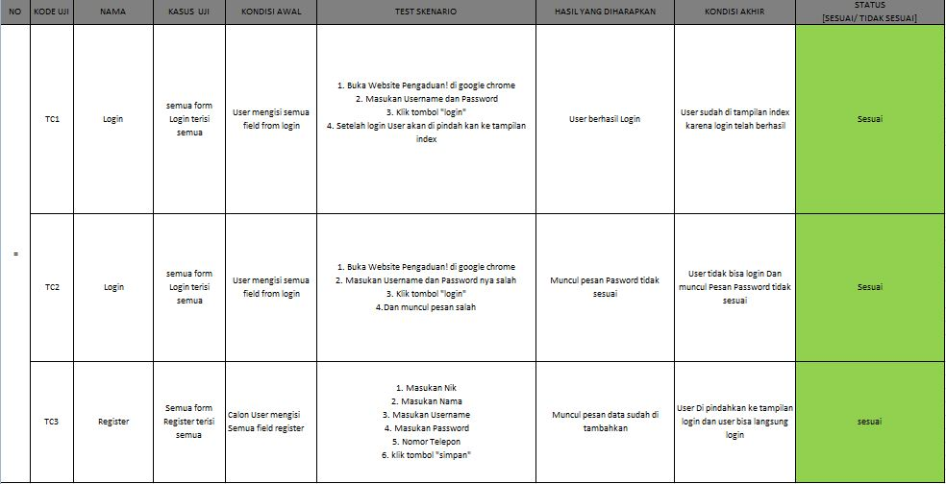

1. REVISI
2. PENENTUANDOMAINDANHOSTING
3. UPLOADWEBKE HOSTING
4. UPLOADWEBKEGITHUB
5. PEMBUATANUSERGUIDANCE